INTERNATIONAL SEMINAR:

Improvement of Road Network Resilience
“Strategies for Cost-Effective Climate Change Adaptation and Sustainable Development”

12 – 14 November 2025
Maputo – Mozambique
Second Announcement

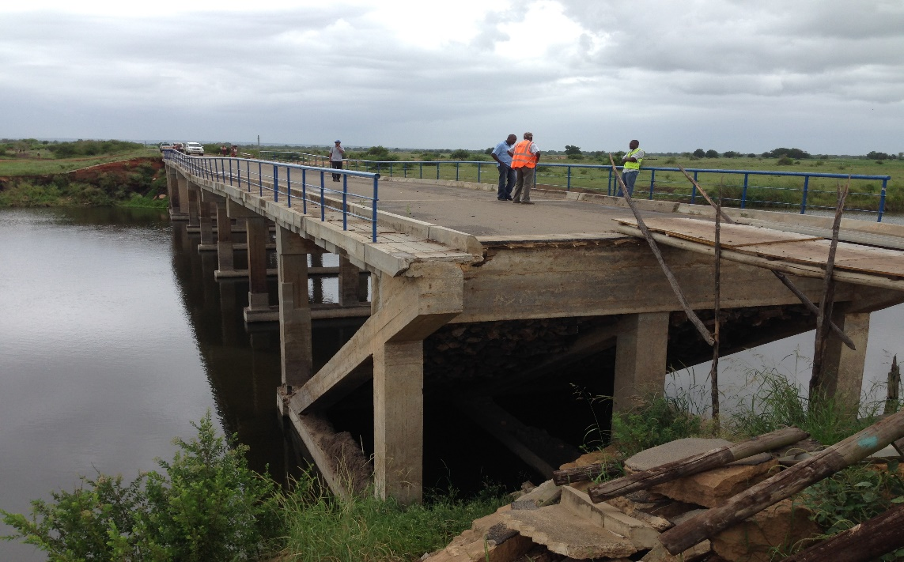

Co-Organized by:
- PIARC
- The World Bank
- Ministry of Transport and Logistic
- National Roads Administration
- Road Fund
Introduction
PIARC (the World Road Association) is a non-profit, non-political organization whose mission includes organizing forums, disseminating good practices, and promoting efficient road and road transport decision support tools.
Since 1909, the Association has been organizing a program of international seminars as part of its work, strengthening its presence in the world, and contributing for improvement of the transport services around the world.
The Technical Committee 1.4 "Planning the Resilience of Road Networks - Climate change and other hazards" in the 2024-2027 cycle focuses on strategic, tactical, and applied planning aspects of enhancing resilience. It covers methodologies and approaches for more resilient network planning and road infrastructure designs which reduce risk, are better prepared, more robust, and are able to respond and recover other hazard events.
In joint collaboration, PIARC Technical Committee 1.4, the World Bank and Mozambique’s Ministry of Transport and Logistic, invite you to participate in an upcoming International Seminar on “Improvement of Road Network Resilience: Strategies for Cost-Effective Climate Change Adaptation and Sustainable Development Climate Resilient Pavements” to be held in Maputo, Mozambique from 12th to 14th November 2025.
Objectives of the Seminar
This Seminar’s main objective is to share knowledge and experience aiming at making road networks more resilient to climate change. It will discuss the benefits of investments in resilience such as enhanced safety, reduced risk of traffic disruption and economic losses, cost savings over time, improved environmental sustainability, enhanced mobility and connectivity, and better preparedness for impacts of climate change.
Cost-effective strategies are important to achieve these benefits while and overcoming barriers such as higher initial construction costs and complex design processes, as well as other financial and political barriers.
Target Audience
The PIARC seminar is intended for:
- Road sector professionals (road administrations/agencies and public services, project managers, public works institutions, engineering works and consulting firms, road laboratories, etc.);
- Expert members of PIARC (World Road Association)
- Development partners and other entities involved in financing of road infrastructure;
- Experts in climate change and weather hazards;
- Suppliers of the materials for road construction and maintenance;
- Academia and researchers;
- Engineering students; and
- All interested stakeholders
Information about Mozambique
Mozambique borders Tanzania, Malawi, Zambia, Zimbabwe, South Africa, and Eswatini. Its long Indian Ocean coastline of 2,700 kilometers faces east to Madagascar. About two-thirds of its estimated 33 million people (2022) live and work in rural areas. The country has ample resources, including arable land, abundant water sources, energy, mineral resources, and newly discovered natural gas deposits off its coast. The country has three deep seaports and a relatively large potential labour force. It is also strategically located: four of the six countries it borders are landlocked, hence dependent on Mozambique as a gateway to global markets. Mozambique’s strong ties to the region’s economic
engine, South Africa, underscore the importance of its economic, political, and social development to the stability and growth of Southern Africa as a whole.
Weather
November is a summer season in Mozambique. Daytime temperatures vary between 25°C and 35°C.

Dates and Venue of the Seminar
The Seminar will take place from 12th to 14th November 2025 at:
Centro Internacional de Conferências Joaquim Chissano (Joaquim Chissano International Conference Center). https://cicjc.co.mz/

Maputo, Av. da Marginal
Mozambique
GPS coordinates: -25.9541682, 326088247

Proceedings and languages of the seminar
The Seminar will last for 02 days of technical sessions and one extra day for the technical visit. The first day, November 12th, will be marked by the official opening ceremony of the Seminar with the presence of Members of the Government of Mozambique, PIARC, the World Bank, other development partners and stakeholders.
The Seminar will be divided into topic sessions, and several themes will be integrated into the program (see preliminary program below). Each session will consist of several presentations by the PIARC Technical Committee members, World Bank, Mozambique, and Association of Southern Africa Road Agencies (ASANRA) experts. At the end of each session, a debate will be organized to discuss the various aspects covered in the presentations with the audience.
On the 3rd day there will be a site visit to the Moamba bridge project located about 60 km of Maputo (one hour travelling distance), where some works were done recently to improve its resilience.
The languages used in the seminar will be Portuguese and English with simultaneous translation.

Themes
The Seminar provides an opportunity for speakers to address policy, technical and operational issues and will focus on the following major themes:
- Enlarge resilience to all hazards on top of climate change.
- Organizational resilience.
- Resilience to prevent damage of road infrastructure (past years impacts).
- Resilience of unpaved roads (rural accessibility).
- Policy framework for resilient infrastructure in Africa.
- PIARC work on resilience.
- Importance of road maintenance to achieve resilience
- Resilience / adaptation to climate change.
- Cost & benefits of resilience,
- Funding of resilience.
- Use of data (including new data sources) for road resilience, prioritization of risks, programs and interventions.
- Uncertainty and decisions (forecast of future climate).

Program of the Seminar
The following sessions are included for the Seminar:
Session 1: Policy framework for resilient road infrastructure in Africa and beyond
Session 2: Resilience and adaption of road infrastructure to climate change and other hazards
Session 3: Approaches to cost and benefits of resilience for roads
Session 4: Practical case studies and lessons learned on strategies for cost-effective climate change adaptation and sustainable development
Session 5: Planning, asset management and funding for road resilience

The following Panel discussions will also be part of the Seminar:
Panel discussion 1: Post disaster recovery and building back better
Panel discussion 2: Future for resilience new data and future climate

Preliminary Program
Day 1:

08:00 - 09:00 | Day 1 Registration
09:00 - 9:55 | Opening session
9:00 - 9.10 | Welcoming words | Miguel Coanai, Deputy General Director of ANE, First Delegate of Mozambique
9:10 - 9:25 | Welcoming words | World Bank representative
9:25 - 9:35 | PIARC Institutional Presentation | PIARC General Secretariat representative
9:35 - 9:45 | PIARC Technical Committee 1.4 | Marie Colin, Chair of PIARC Technical Committee 1.4 Road Resilience
9:45 - 9:55 | Offcial opening | Minister of Transport and Logistic
9:55 - 10:30 | Keynote session
10:30 - 11:00 | Coffee break
11:00 - 13:00 | Session 1: Policy framework for roads and road networks resilient infrastructure in Africa and beyond
13:00 - 14:00 | Lunch
14:00 - 16:00 | Session 2: Resilience and adaption of road infrastructure to climate change and other hazards
16:00-16:30 | Coffee break
16:30-18:00 | Panel discussion 1: Post disaster recovery and building back better
18:00 | Closing Day1
Day 2:

8:30 - 09:00 | Day 2 Registration
9:00 - 11:00 | Session 3: Cost and benefits of resilience for roads
11:00-11:30 | Coffee break
11:30 - 13:00 | Session 4: Planning, asset management and funding for road resilience
13:00 - 14:00 | Lunch
14:00 - 16:00 | Session 5: Practical case studies and lessons learned on strategies for cost-effective climate change adaptation and sustainable development
16:00-16:30 | Coffee break
16:30-17:45 | Panel discussion 2: Future for resilience new data and future climate
17:40-18:00 | Closing Session
Day 3:

8:30 - 09:00 | Arrival of the Delegates at the Seminar Venue
9:00 | Bus Departure to site visit
09:40-12:00 | Site visit to Moamba Bridge
12:00 | Bus Departure to Seminar venue
13:00 - 14:00 | Lunch

Accommodation
The list of recommended hotels and prices for overnight stays near the conference centre is presented below.
Name of the hotel | Polana Serena Hotel
Hotel Star Rating | 5*
Website | https://www.serenahotels.com/polana/
Email Address | reservations.polana@serenahotels.com
Contact | 21 241700
Rate | From 195US$ per Nigth
Name of the hotel | Radisson Blu Hotel & Residence, Maputo
Hotel Star Rating | 5*
Website | https://www.radissonhotels.com/en-us/hotels/radisson-blu-maputo
Email Address | reservations.maputo@radissonblu.com
Contact | 21242400/85 010 27 28
Rate | From EUR 130 Per Night
Name of the hotel | City Lodge Hotel-Maputo
Hotel Star Rating | 4*
Website | https://citylodgehotels.com/contact-uswww.radissonhotels.com/en-us/hotels/radisson-blu-maputo
Email Address | clmaputo.resv@citylodgehotels.com
Contact | +258 83 301 3652
Rate | From US$ 105 Per Night
Name of the hotel | Soutthern Sun-Maputo
Hotel Star Rating | 4*
Website | https://www.southernsun.com/southern-sun-maputo
Email Address | ssmaputo.reservations@southernsun.com
Contact | 21495921/+258844244279
Rate | From US$ 179 Per Night
Name of the hotel | StayEasy Maputo
Hotel Star Rating | 3*
Website | https://www.stayeasymaputo.com
Email Address | semaputo.reservations@southernsun.com
Contact | +258 20 607030
Rate | From US$ 95 Per Night

Travel and transport
The capital, Maputo, is well linked to the rest of the world through Maputo international airport. Taxi services are available from the airport.
Visa procedures
Some countries are visa exempted to enter in Mozambique. However, the documents required to apply for a visa to Mozambique are standard, and procedures, applications, and deadlines may vary depending on nationality of traveler. For full information, please contact the Mozambique embassy or consulate in your country. Details can be obtained from the link below.
https://www.evisa.gov.mz

Organising Committee
Name | Institution
Miguel Coanai | ANE, Chair of the Organizing committee
Irene Langa Simões | Road Fund, Mozambique
Cilésia Chipepo | Road Fund, Mozambique
Calado Ouana | ANE, Mozambique
Carla Mangane | ANE, Mozambique
Marie Colin | TC 1.4 Chair TC1.4, France
Juan Fernando Mendoza | TC 1.4 Spanish-Speaking Secretary, Mexico
Stuart Woods | TC 1.4 English-Spaking Secretary, New Zealand
Nkululeko Leta | TC 1.4 Member, South Africa
Miguel Caso Florez | PIARC Technical Director
Kaouther Matcha/Hyunji Kim | PIARC Technical Advisor
Vincent Vesin | World Bank
Emmanuel Taban | World Bank

Form of participation and registration
The seminar will be in person participation and you are kindly requested to register as soon as possible as the seats are limited.
REGISTER NOW

https://www.piarcseminar-mozambique.com/event-details/improvement-of-road-network-resilience-2/form

Seminar Contact Person

For any further information or clarification that you may require, please contact Mr. Calado Ouana: caladoouana@yahoo.com.br

